System ID Report
H093,H095

System Description
The selected system is a two-wheeled self-balancing robot model as an Inverted Pendulum mounted on a moving base. The objective of the system is to maintain an upright position by dynamically adjusting wheel motion in response to tilt.

Real-World Applications
Personal Transport Systems
Self-balancing robots are used in devices like the Segway PT, where dynamic balancing allows smooth and stable human transportation.
Warehouse & Industrial Robotics
Used in autonomous robots for material handling, where balance control enables efficient navigation in tight spaces and uneven loads.
Assistive Mobility Devices
Applied in smart wheelchairs and mobility aids to maintain stability and improve user safety on inclined or uneven surfaces.

Inputs, Outputs, and State Variables
Input
- $u(t)=2T_{w}$: Total motor torque applied to wheels

Disturbance Input
- $F_{d}$: External disturbance force acting at the top of the body

Outputs
- $θ(t)$: Tilt angle
- $x(t)$: Horizontal position
State Variables
- $x_{1}=x$: Position
- $x_{2}=\dot{x}$: Velocity
- $x_{3}=θ$: Tilt angle
- $x_{4}=\dot{θ}$: Angular velocity
System Parameters (From FBD)
- $M$: Mass of robot body
- $m$: Mass of each wheel
- $l_{CG}$: Distance from wheel axis to center of mass
- $r$: Wheel radius
- $I_{CG}$: Moment of inertia of body
- $J$: Moment of inertia of each wheel
- $g$: Gravitational acceleration

Degrees of Freedom (DOF)
DOF = 2
Justification:
- Horizontal translation of system - $x$
- Rotation of body - $θ$
Wheel rotation $ϕ$is not independent due to rolling constraint:
$$x=rϕ$$

Assumptions with Physical Justification

- No Slip Condition
Wheels roll without slipping ensures $x=rϕ$
- Rigid Body Approximation
Body and wheels do not deform
- Planar Motion
Motion restricted to 2D plane justified by symmetric wheels
- Negligible Air Resistance
Effect is very small compared to gravity and motor forces
- Uniform Mass Distribution
Allows use of $I_{CG}$as constant

FBD
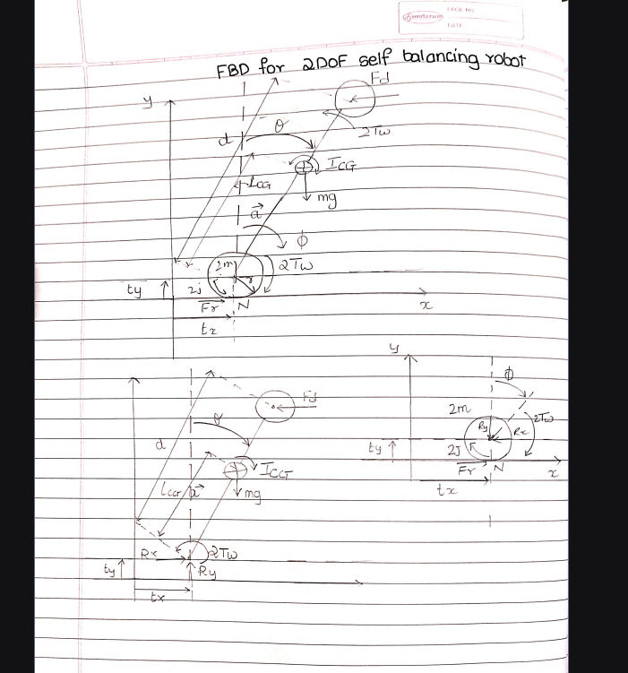

Forces and Torques Included:
On Robot Body:
- $Mg$: downward at COM
- $F_{d}$: external disturbance
- $R_{x},R_{y}$: reaction forces at joint
- Torque due to motion

On Wheels:
- $2T_{w}$: input motor torque
- $F_{r}$: friction force at ground
- $N$: normal reaction
- $2J$: rotational inertia

Coordinate System and Sign Convention
- $x$: positive to the right
- $θ$: positive when tilting forward (clockwise)
- $\dot{x},\ddot{x}$: positive in forward direction
- $\dot{θ},\ddot{θ}$: positive in same direction
- $u=2T_{w}$: positive torque drives robot forward

Generalized Coordinates
- $x(t)$: Horizontal displacement of the robot (along x-axis)
- $θ(t)$: Tilt angle of the robot body measured from the vertical

Friction force $F_{r}$is internal which is eliminated in final equations
Motor torque $2T_{w}$is only control input
Gravity $Mg$causes instability must be counteracted

